PHAS E I

Below are comments from the review Mike and Dan did of the Program Locator on Tuesday. If you think it would help, you and Mike should talk about these on the phone. The changes focus on Interactive, Government, and Asset Maps.

I’m rethinking how we present “The Rest Of The Story” – We are deciding how to handle this, moving forward.

* InteractiveMap.aspx

General

- We will wait until the server change to see if it improves performance, but zooming, and re-painting are still taking far too long.

- There are still script errors, using Firefox… whenever I zoom, it breaks, and when I try to show community boundaries, it breaks multiple times before drawing all of them. Is your team seeing this? How is the team testing its code?

- We would like to see a text box with instructional text appear over the map when the user first arrives at a map view, that allows us to give detailed explanations regarding what the user will see when they hide the instructional text box and reveal the map. Obviously this needs a button or a link that allows the user to hide the text box when they finish reading. (Instructional text coming soon.)

Zooming

- Is there a zoom level between the default zoom (When you first arrive at this page), and level immediately below it? In other words, does Google have standard zoom levels, or are zoom levels customizable? We would like to show a zoom extent somewhere between these two levels that zooms exactly to the northern and southern bounds of the Chicago city boundary – to allow maximum icon size when you first see this page.

- Is it possible to create zoom levels in between each of the available options now?

- Can we add a button or a link somewhere that allows a user to go back to “previous” map zoom extent without having to use the back button on the browser or press the “-“ zoom tool several times? Or is zooming all the way back out manually after zooming to a community boundary the only way to do this?

- I like the legend, but is there a way the user can choose to make it collapsible/expandable, or to turn it off and on?

- What solutions are available for printing a final map view?

- The map symbols you have chosen are nice, but are inconsistent with the symbols we are using for static maps. We would like them to be consistent. Can we send bitmaps to replace the symbols currently used? What size, format, etc.?

Schools Tab

- When selecting or deselecting school types (elementary, junior, senior) the legend does not seem to automatically reflect which are showing and which are not.

- The geographic location of Schools displayed is inaccurate at certain zoom levels. In the image below, 1313 S. Sacramento should be in the northwest corner of Douglas Park, south of Roosevelt. This might be an issue with the the coordinate system and geographic projection Google is expecting versus those specified when the shapefile was created. Do you know which coordinate system and projection you need?

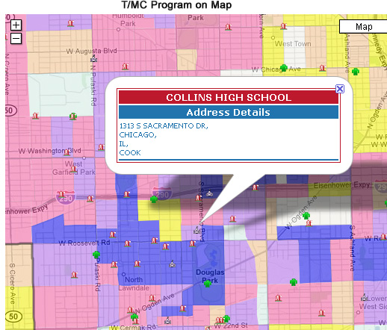

Programs Tab

- As in the case of Collins High in the image above, geographic locations of programs are pretty far off, and seem to move depending on zoom level. Probably related to issue above, but the distance between points displayed and reality is severe. We’re about 3 blocks off in this screen capture.

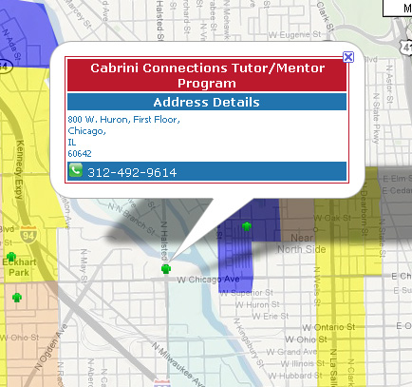.

- Also, “All” Programs is not actually retrieving any programs. (See screen captures below.)

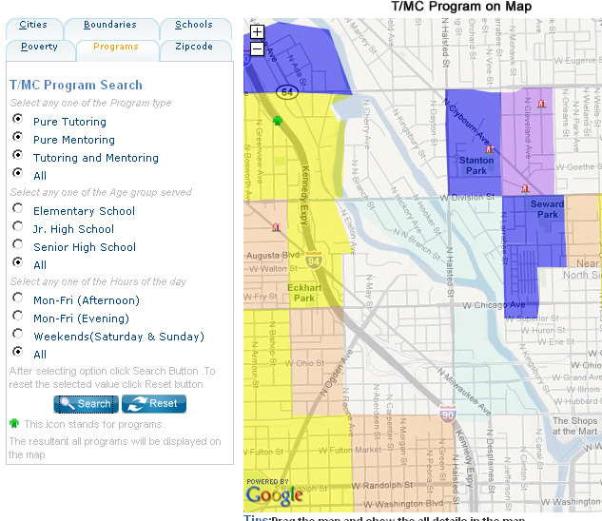

- On the bubble/text box that pops up when a user hovers the mouse point over a program icon, the program’s website link is still needed.

- Radio buttons on The T/MC Program Search need to be replaced with check boxes that allow users to select combinations of type, age group, and hours.

- Can we add a text box to search for a particular program by name?

- Interactive data not updating real time (Highsight was added by Dan yesterday, and appears in our program locator on the right, but did not show up in the interactive data on the left. Are we pulling from the same live data?)

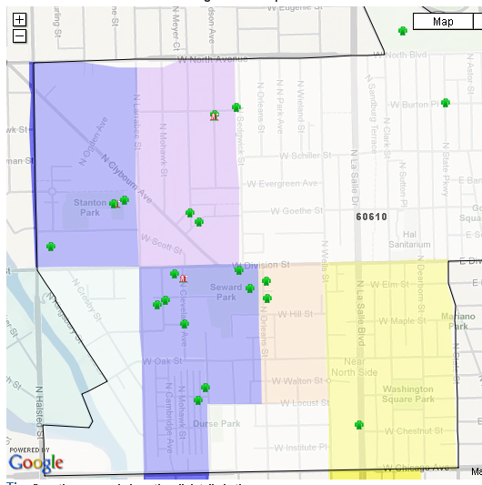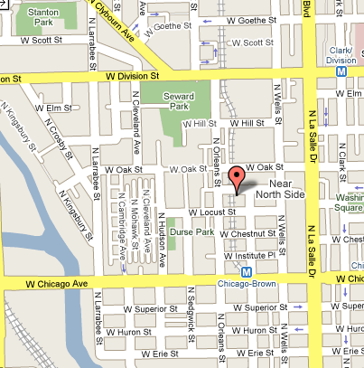

Boundaries Tab

- When I click onto a community boundary, and it zooms in, the boundaries should still show for all neighborhoods in case I want to manually zoom out, or move around, or show the surrounding communities.

* AssetMap.aspx

- Do you still need Insurance Company data, or is it just not loaded yet?

- Turning on Catholic churches after Baptist churches seems to create an infinite “Loading…” message.

- The text box/bubble that pops up on Mt. Sinai Hospital in the North Lawndale community, is missing data, and shows “Null” where address and information should be.

* GovernmentMapGalleries.aspx

- I like the “More...” link that has been added to the introduction text. Can we do the same thing to the text of the top row of thumbnails? (U.S. Congressional Districts, Illinois State Senate Districts, Illinois State Legislature Districts)… Hide text beginning with “Maps can be used as looks for…”

- These three sections (U.S. Congressional Districts, Illinois State Senate Districts, Illinois State Legislature Districts) need the blog links we sent you in the spec to appear below the thumbnails.

- The header “Chicago Neighborhoods” needs to be replaced with “Cook County Government”

- You can remove the text associated with the three images on the bottom row, and replace it with “Coming Soon.”

- too much text on main menu – how to shorten this and show full text in bubble?

* GovernmentMap.aspx

- The boundaries of the districts do not contrast enough with the map background. It is confusing to look at. We need a new way to make the district we focus on stand out from those around it. Perhaps a different color for the district we focus on, or shade the backgrounds of those around it? Or perhaps the line needs to draw above the assets?

- If I select the 5th Congressional district, it doesn’t zoom in to the bounds of the boundary polygon. I have to manually zoom into the bounds.

- If I then select the 7th Congressional district, I lose the zoom extent I was using, it zooms all the way out, and then I have to zoom back in. When you select a district (or any boundary – zip codes,, communities, etc.) the map should automatically zoom into (or out to) the bounds of the boundary polygon.

- When I switched from 5th to 7th district, the label for the 5th district remained painted to the screen.

- A user should not need to show the boundary for a combination of congressional, senate, or legislative districts. If a user, for example, is displaying a senate district, and then switches tabs and chooses a legislature district, the senate boundaries should automatically disappear.

- Legislature districts do not seem to load currently.

- When I zoom to a district in my static maps, I occasionally need to shade out neighboring districts to make these large geographic areas stand out. Is this possible, using transparent gray fill colors for neighboring district polygons?

PHASE II

After Interactive, Government, and Asset Maps functionality is ironed out, and the code is moved to Brinkster, we need to determine:

- What will be the easiest way for us to modify code here? What software do we need to edit .aspx code?

- We need a way to pass tagged data into the program, so that if we link to the interactive map, and want to show specific zoom levels, or boundaries, or assets, the link that sends the user to the interactive map passes these variables into the program? Is this possible now, or is this something we need to discuss and plan?

